MODULE 3

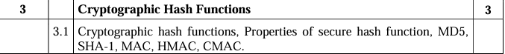

PYQ

Q. What characteristics are needed in secure hash functions? Explain secure hash algorithm on 512 bit (or SHA-1)-IMP

->Secure hash functions are essential cryptographic tools used in various applications, including digital signatures, message authentication codes (MACs), and password hashing. They take an input (or message) of any size and produce a fixed-size hash value, typically of a much smaller size. Here are the key characteristics needed in secure hash functions:

1. **Preimage Resistance**: Given a hash value h, it should be computationally infeasible to find any message m such that H(m) = h. In simpler terms, it should be difficult to reverse-engineer the input from the output.

2. **Second Preimage Resistance**: Given a message m1, it should be computationally infeasible to find another message m2 ≠ m1 such that H(m1) = H(m2). This ensures that given a specific input, it's hard to find another input that produces the same hash.

3. **Collision Resistance**: It should be computationally infeasible to find any two distinct messages m1 and m2 such that H(m1) = H(m2). This is similar to second preimage resistance but applies to any pair of messages rather than a specific message.

4. **Deterministic**: For any given input, the hash function must produce the same output every time it's executed.

5. **Fast Computation**: The hash function should be computationally efficient, allowing it to process large amounts of data quickly.

6. **Small Changes in Input Should Produce Large Changes in Output**: A small change in the input message should result in a significantly different hash value. This property, known as the avalanche effect, ensures that even minor alterations to the input significantly alter the resulting hash value.

SHA-1 (Secure Hash Algorithm 1) is a widely used cryptographic hash function that was designed by the National Security Agency (NSA) and published by the National Institute of Standards and Technology (NIST) in 1993. However, due to vulnerabilities discovered over time, its usage has been deprecated for most cryptographic purposes.SHA-1 produces a 160-bit (20-byte) hash value, typically represented as a 40-digit hexadecimal number. While you mentioned SHA-1, it's worth noting that there's no SHA-1 with a 512-bit hash output. However, there are SHA-2 variants such as SHA-512, which produce a 512-bit hash.The Secure Hash Algorithm (SHA) family includes several algorithms, such as SHA-0, SHA-1, SHA-2 (which includes SHA-224, SHA-256, SHA-384, SHA-512, SHA-512/224, and SHA-512/256), and SHA-3 (which is a separate standard). SHA-1's structure involves several rounds of processing, where the input message is processed in blocks, and each block undergoes a series of transformations. The final output is a 160-bit hash value.

SHA stands for Secure Hash Algorithm. It's a family of cryptographic hash functions designed by the National Security Agency (NSA) and published by the National Institute of Standards and Technology (NIST). These hash functions take an input (or message) of any size and produce a fixed-size hash value, typically represented as a string of hexadecimal characters. The length of the hash value varies depending on the specific variant of SHA being used.

512 bits refers to the length of the hash output. In the context of SHA, 512 bits means the resulting hash value will consist of 512 binary digits (1s and 0s). This is equivalent to 64 bytes or 128 hexadecimal characters when represented in hexadecimal notation.

Now, let's go through the process of computing a SHA-512 hash value using an example:

Example Input Message: "Hello, World!"

Step 1: Message Padding

- The input message is padded to ensure its length is a multiple of the block size. For SHA-512, the block size is 1024 bits (128 bytes).

- In our example, the ASCII representation of "Hello, World!" is 13 bytes. To pad it to the nearest multiple of 128 bytes, we add padding bytes.

- Padding usually consists of a single '1' bit followed by a series of '0' bits, with the last 128 bits representing the length of the original message.

After padding, the message might look like this:

```

48 65 6C 6C 6F 2C 20 57 6F 72 6C 64 21 80 00 ... 00 00 00 00 00 00 00 00 00 00 00 00 00 00 00 80

```

Step 2: Message Processing

- The padded message is divided into blocks, each consisting of 1024 bits (128 bytes) for SHA-512.

- Each block undergoes a series of transformations, including bitwise operations, modular additions, and logical functions.

- These transformations are performed in multiple rounds, with each round using a different set of constants and functions.

Step 3: Final Hash Value

- After processing all blocks, the final hash value is obtained.

- The hash value is typically represented as a string of hexadecimal characters.

For our example input message "Hello, World!", the SHA-512 hash value might be:

```

2CF24DBA5FB0A30E26E83B2AC5B9E29E1B161e5c1fa7425e73043362938b9824

```

This hash value uniquely represents the input message "Hello, World!" and any change to the input message would result in a completely different hash value. Additionally, it's computationally infeasible to reverse-engineer the original message from the hash value.Q. Comparison between HMAC , CBC-MAC , CMAC(10M)-IMP

Q. What goals are served using a message digest? Explain using MD5(10M)-IMP

->Message digests, also known as hash values or hash codes, serve several important goals in cryptography and computer security. One commonly used hash function is MD5 (Message Digest Algorithm 5). Here are the goals served by message digests, illustrated using MD5:

1. **Data Integrity Verification**: Message digests ensure that data hasn't been tampered with during transmission or storage. By calculating the MD5 hash of a file or message before and after transmission, you can compare the two hash values. If they match, it's highly likely that the data remains intact. Even a minor alteration in the original data would produce a vastly different MD5 hash, making it easy to detect changes.

2. **Data Authentication**: Hash functions like MD5 are used to authenticate data, confirming that it originates from a trusted source. By sharing the MD5 hash of a file or message along with the data, recipients can calculate the hash themselves and compare it to the provided hash. If the two hashes match, the recipient can trust the integrity and authenticity of the data.

3. **Password Storage**: In password-based authentication systems, storing plaintext passwords is insecure. Instead, systems store the hash values of passwords. When a user enters their password, the system calculates the hash of the input and compares it to the stored hash. This way, even if the password database is compromised, attackers won't immediately gain access to user passwords.

4. **Digital Signatures**: Message digests are a crucial component of digital signatures. When creating a digital signature, the sender calculates the hash of the message and then encrypts this hash using their private key. The recipient can decrypt the signature using the sender's public key and verify the message's integrity by comparing the decrypted hash with a newly calculated hash of the received message.

MD5, while once widely used, is now considered insecure due to vulnerabilities that have been discovered over time, including collision attacks. Therefore, for new systems and applications, more secure hash functions like SHA-256 or SHA-3 are recommended. However, the fundamental goals served by message digests remain the same regardless of the specific hash function used.

MD5 (Message Digest Algorithm 5) is a widely used cryptographic hash function designed by Ronald Rivest in 1991. It produces a 128-bit (16-byte) hash value, typically represented as a 32-digit hexadecimal number. MD5 is no longer considered secure for cryptographic purposes due to vulnerabilities discovered over the years, but it still finds some non-security-related uses, such as checksums for data integrity verification.

Let's walk through how MD5 works with an example and illustrate the goals it serves:

Example Input Message: "Hello, World!"

1. **Message Padding**:

- MD5 processes messages in 512-bit (64-byte) blocks. If the message length is not a multiple of 512 bits, padding is added to the message.

- The padding starts with a single '1' bit, followed by the necessary number of '0' bits to make the length of the message congruent to 448 bits modulo 512.

- Finally, the length of the original message is encoded as a 64-bit little-endian integer and appended to the padded message.

For our example input message "Hello, World!", the padded message might look like this:

```

48 65 6C 6C 6F 2C 20 57 6F 72 6C 64 21 80 00 ... 00 00 00 00 00 00 00 00 00 00 00 00 00 00 00 28

```

2. **Initial Hash Values**:

- MD5 initializes four 32-bit words (A, B, C, D) as predetermined constants, usually derived from the fractional parts of the square roots of small primes.

For MD5, the initial hash values are:

```

A = 0x67452301

B = 0xEFCDAB89

C = 0x98BADCFE

D = 0x10325476

```

3. **Message Processing**:

- The padded message is divided into 512-bit blocks.

- Each block undergoes a series of four rounds of processing, with each round consisting of 16 similar operations that manipulate the four hash values and the current block of the message.

- These operations include bitwise logical functions (AND, OR, XOR), modular addition, left rotation, and non-linear functions that depend on the bitwise logical operations.

4. **Final Hash Value**:

- After processing all blocks, the final hash value is obtained.

- The hash value is typically represented as a string of hexadecimal characters.

For our example input message "Hello, World!", the MD5 hash value might be:

```

65a8e27d8879283831b664bd8b7f0ad4

```

Goals Served by MD5:

- **Data Integrity Verification**: The MD5 hash can be recalculated at the recipient's end, and if it matches the hash provided by the sender, it verifies the integrity of the data.

- **Data Authentication**: By comparing the MD5 hash calculated by the recipient with the one provided by the sender, the recipient can authenticate the source of the data.

- **Password Storage**: MD5 was previously used to store password hashes in databases, ensuring that plaintext passwords were not stored and providing a layer of security in case of a data breach.

- **Checksums and Verification**: MD5 checksums are used to verify the integrity of files and data during transmission or storage. If the calculated MD5 hash of a file matches the provided hash, it confirms that the file has not been tampered with.

Q. Differentiate between SHA-1 and MD5(x2 – SHA vs MD-5) -IMP,IMP

| **Feature** | **SHA-1** | **MD5** |
| --- | --- | --- |
| Algorithm Type | SHA-1 is a member of the SHA family, designed by the NSA. | MD5 is a member of the MD (Message Digest) family, designed by Ronald Rivest. |
| Bit Length | Produces a 160-bit hash value (20 bytes). | Produces a 128-bit hash value (16 bytes). |
| Security | Vulnerable to collision attacks, considered cryptographically weak. | Also vulnerable to collision attacks, considered even weaker than SHA-1. |
| Rounds | Uses 80 rounds of processing. | Uses 64 rounds of processing. |
| Block Size | Processes messages in 512-bit blocks. | Also processes messages in 512-bit blocks. |
| Performance | Generally slower than MD5. | Generally faster than SHA-1. |
| Usage | Widely used in the past but now deprecated due to security vulnerabilities. | Was widely used but is now deprecated due to significant security weaknesses. |
| Strength | Provides better security than MD5 but still not considered secure. | Weaker security compared to SHA-1; highly vulnerable to attacks. |
| Example Application | Used in digital signatures, SSL/TLS certificates, and other cryptographic protocols. | Used in password hashing, checksums, and data integrity verification. |
| Collision Resistance | Vulnerable to collision attacks; two different inputs can produce the same hash. | Vulnerable to collision attacks; same weaknesses as SHA-1 but with a shorter output. |
| Output Size | Produces a 160-bit hash value. | Produces a 128-bit hash value. |
| Length Extension Attacks | Vulnerable to length extension attacks. | Not vulnerable to length extension attacks. |
| Status | Deprecated for most cryptographic applications. | Deprecated for most cryptographic applications. |
| Replacement | Being replaced by more secure hash functions like SHA-256 or SHA-3. | Being replaced by more secure hash functions like SHA-256 or SHA-3. |
| Example Hash Value | "2fd4e1c67a2d28fced849ee1bb76e7391b93eb12" (SHA-1 hash of "hello") | "5d41402abc4b2a76b9719d911017c592" (MD5 hash of "hello") |

**Explanation of Differences:**

1. **Algorithm Type**: SHA-1 and MD5 belong to different families of hash functions, with SHA-1 being part of the SHA family and MD5 being part of the MD family.
2. **Bit Length**: SHA-1 produces a 160-bit hash value, while MD5 produces a 128-bit hash value.
3. **Security**: Both SHA-1 and MD5 are vulnerable to collision attacks, but SHA-1 is generally considered more secure than MD5.
4. **Rounds**: SHA-1 uses 80 rounds of processing, while MD5 uses 64 rounds.
5. **Block Size**: Both algorithms process messages in 512-bit blocks.
6. **Performance**: SHA-1 is generally slower than MD5.
7. **Usage**: SHA-1 is commonly used in digital signatures and cryptographic protocols, while MD5 is used in password hashing and data integrity verification.
8. **Collision Resistance**: Both SHA-1 and MD5 are vulnerable to collision attacks, but SHA-1 has a longer hash output.
9. **Output Size**: SHA-1 produces a longer hash value compared to MD5.
10. **Length Extension Attacks**: SHA-1 is vulnerable to length extension attacks, whereas MD5 is not.
11. **Status**: Both SHA-1 and MD5 are deprecated for most cryptographic applications due to security vulnerabilities.
12. **Replacement**: Both algorithms are being replaced by more secure hash functions like SHA-256 or SHA-3.

These points highlight the key differences between SHA-1 and MD5, including their security, performance, and usage in cryptographic applications.

Top of Form

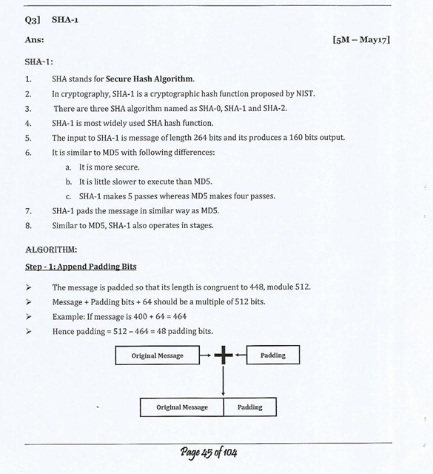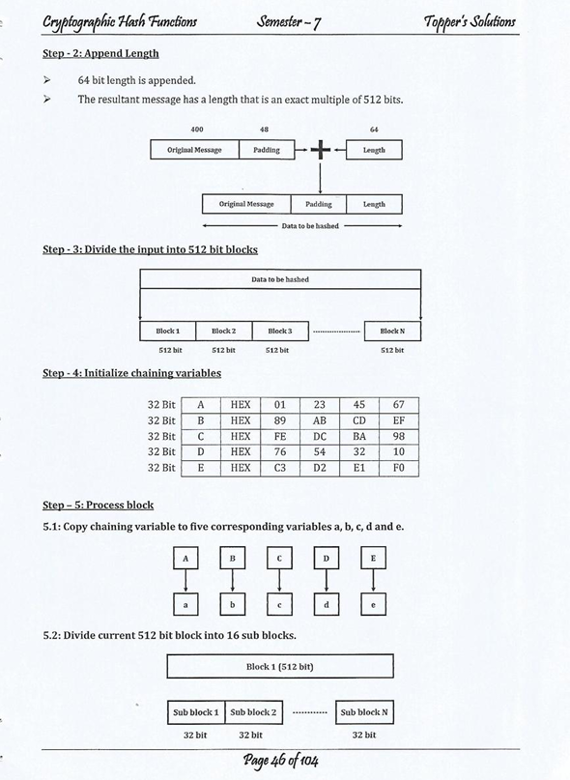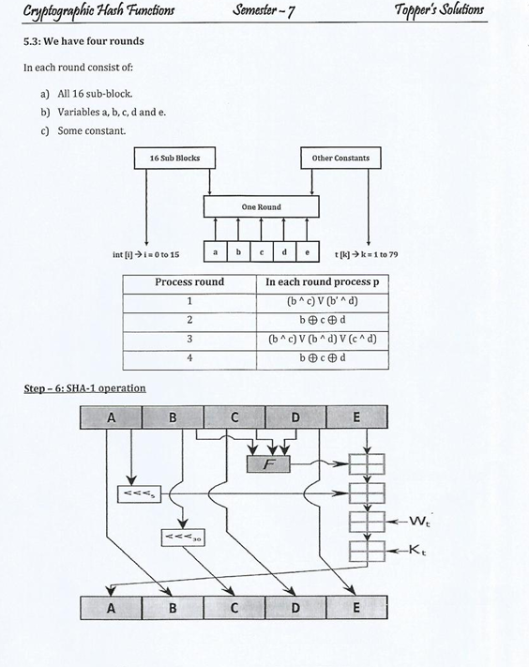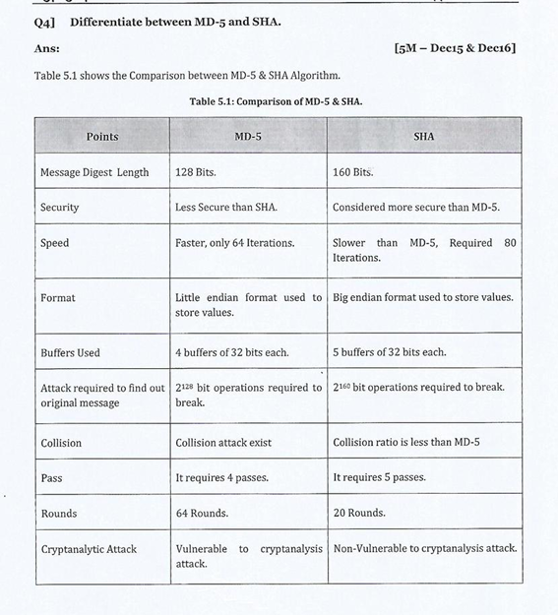

Q. What are properties of hash functions? Explain role of hash function in security.-IMP, IMP

-> Hash functions are essential cryptographic tools with several properties that make them invaluable in ensuring security in various applications. Here are the key properties of hash functions:

1. **Deterministic**: For any given input, a hash function always produces the same output. This deterministic nature ensures consistency and predictability in the hashing process.

2. **Fast Computation**: Hash functions should be computationally efficient, allowing them to process large amounts of data quickly. This efficiency enables their widespread use in various applications, including digital signatures, password hashing, and data integrity verification.

3. **Preimage Resistance**: Given a hash value, it should be computationally infeasible to find any input that produces that hash value. In other words, it should be difficult to reverse-engineer the original input from the hash output.

4. **Second Preimage Resistance**: Given a specific input, it should be computationally infeasible to find another input that produces the same hash value. This property ensures that it's challenging to find collisions where two different inputs produce the same hash.

5. **Collision Resistance**: It should be computationally infeasible to find any two distinct inputs that produce the same hash value. This property ensures that it's difficult to find collisions even when searching for them deliberately.

6. **Avalanche Effect**: A small change in the input should produce a significantly different hash value. This property ensures that even minor alterations to the input result in vastly different hash outputs, providing robustness against intentional tampering or accidental errors.

7. **Fixed Output Size**: Hash functions produce output of a fixed size, regardless of the size of the input. This property allows hash values to be efficiently stored, transmitted, and compared.

8. **Efficiently Verifiable**: It should be easy to verify whether a given hash value corresponds to a specific input. This property is crucial for applications such as data integrity verification and password authentication.

Now, let's delve into the role of hash functions in security:

1. **Data Integrity**: Hash functions play a vital role in ensuring the integrity of data. By computing the hash value of a piece of data and comparing it to a previously computed hash value, one can quickly determine whether the data has been altered or corrupted.

2. **Data Authentication**: Hash functions are used to authenticate data by generating a hash value or message digest. This digest, when digitally signed by a sender's private key, provides assurance that the data originated from the sender and hasn't been tampered with during transmission.

3. **Password Storage**: Hash functions are commonly used to securely store passwords in databases. Instead of storing plaintext passwords, the system stores the hash values of passwords. During authentication, the system hashes the user's input and compares it with the stored hash value.

4. **Digital Signatures**: Hash functions are a fundamental component of digital signatures. The hash of a message is encrypted with the sender's private key to create a digital signature. The recipient can verify the signature by decrypting it with the sender's public key and comparing the resulting hash with a recalculated hash of the message.

5. **Checksums and Message Digests**: Hash functions are used to compute checksums and message digests for data verification. By comparing the hash values of transmitted data with precomputed values, errors or tampering can be detected.

6. **Data Deduplication**: In storage systems, hash functions are used for data deduplication, where duplicate copies of data are identified and eliminated based on their hash values. This optimizes storage space and improves efficiency.

Overall, hash functions are indispensable tools in ensuring data integrity, authentication, and security in various applications, providing a robust foundation for modern cryptographic systems. Their properties make them well-suited for use in secure communication, data storage, and authentication mechanisms.

Q. Define the properties and applications of Hash function.(X2)

->Hash functions are cryptographic algorithms that take an input (or message) and produce a fixed-size output, known as a hash value or hash code. These hash values are unique representations of the input data and possess several properties that make them invaluable in various applications. Let's define the properties and applications of hash functions:

### Properties of Hash Functions:

1. **Deterministic**: For any given input, a hash function always produces the same output. This property ensures consistency and predictability in the hashing process.

2. **Fast Computation**: Hash functions should be computationally efficient, allowing them to process large amounts of data quickly. This efficiency enables their widespread use in various applications.

3. **Preimage Resistance**: Given a hash value, it should be computationally infeasible to find any input that produces that hash value. This property ensures that it's difficult to reverse-engineer the original input from the hash output.

4. **Second Preimage Resistance**: Given a specific input, it should be computationally infeasible to find another input that produces the same hash value. This property ensures that it's challenging to find collisions where two different inputs produce the same hash.

5. **Collision Resistance**: It should be computationally infeasible to find any two distinct inputs that produce the same hash value. This property ensures that it's difficult to find collisions even when searching for them deliberately.

6. **Avalanche Effect**: A small change in the input should produce a significantly different hash value. This property ensures that even minor alterations to the input result in vastly different hash outputs, providing robustness against intentional tampering or accidental errors.

7. **Fixed Output Size**: Hash functions produce output of a fixed size, regardless of the size of the input. This property allows hash values to be efficiently stored, transmitted, and compared.

8. **Efficiently Verifiable**: It should be easy to verify whether a given hash value corresponds to a specific input. This property is crucial for applications such as data integrity verification and password authentication.

### Applications of Hash Functions:

1. **Data Integrity Verification**: Hash functions are used to verify the integrity of data by generating hash values before and after transmission or storage. If the hash values match, it indicates that the data has not been altered or corrupted.

2. **Data Authentication**: Hash functions are used to authenticate data by generating hash values or message digests. These digests, when digitally signed, provide assurance that the data originated from a trusted source and hasn't been tampered with.

3. **Password Storage**: Hash functions are commonly used to securely store passwords in databases. Instead of storing plaintext passwords, systems store the hash values of passwords. During authentication, the system hashes the user's input and compares it with the stored hash value.

4. **Digital Signatures**: Hash functions are a fundamental component of digital signatures. The hash of a message is encrypted with a sender's private key to create a digital signature. The recipient can verify the signature by decrypting it with the sender's public key and comparing the resulting hash with a recalculated hash of the message.

5. **Checksums and Message Digests**: Hash functions are used to compute checksums and message digests for data verification. By comparing the hash values of transmitted data with precomputed values, errors or tampering can be detected.

6. **Data Deduplication**: In storage systems, hash functions are used for data deduplication, where duplicate copies of data are identified and eliminated based on their hash values. This optimizes storage space and improves efficiency.

Overall, hash functions play a critical role in ensuring data integrity, authentication, and security in various applications, providing a robust foundation for modern cryptographic systems.

Q. What characteristics are needed in secure hash functions? Explain the operation of secure hash algorithm on 512 bit(10M)

-> Secure hash functions are essential cryptographic tools used in various applications, including digital signatures, message authentication codes (MACs), and password hashing. They are designed to possess several key characteristics to ensure their security and reliability. Let's discuss the characteristics needed in secure hash functions and then explain the operation of a secure hash algorithm on a 512-bit message.

**Characteristics Needed in Secure Hash Functions:**

1. **Preimage Resistance**: Given a hash value ℎ*h*, it should be computationally infeasible to find any message 𝑚*m* such that 𝐻(𝑚)=ℎ*H*(*m*)=*h*. In simpler terms, it should be difficult to reverse-engineer the input from the output.
2. **Second Preimage Resistance**: Given a message 𝑚1*m*1​, it should be computationally infeasible to find another message 𝑚2≠𝑚1*m*2​=*m*1​ such that 𝐻(𝑚1)=𝐻(𝑚2)*H*(*m*1​)=*H*(*m*2​). This ensures that given a specific input, it's hard to find another input that produces the same hash.
3. **Collision Resistance**: It should be computationally infeasible to find any two distinct messages 𝑚1*m*1​ and 𝑚2*m*2​ such that 𝐻(𝑚1)=𝐻(𝑚2)*H*(*m*1​)=*H*(*m*2​). This property ensures that it's difficult to find collisions where different inputs produce the same hash.
4. **Deterministic**: For any given input, the hash function must produce the same output every time it's executed. This ensures consistency and predictability.
5. **Fast Computation**: The hash function should be computationally efficient, allowing it to process large amounts of data quickly.
6. **Small Changes in Input Should Produce Large Changes in Output**: A small change in the input message should result in a significantly different hash value. This property, known as the avalanche effect, ensures that even minor alterations to the input significantly alter the resulting hash value.

**Operation of a Secure Hash Algorithm on 512 Bits:**

Secure hash algorithms, such as SHA-2 (Secure Hash Algorithm 2), operate by dividing the input message into fixed-size blocks and processing each block sequentially. Here's how a secure hash algorithm operates on a 512-bit message:

1. **Message Padding**: If the length of the input message is not a multiple of the block size, it is padded to ensure it aligns with the block boundary. Padding typically includes a single '1' bit followed by '0' bits until reaching a certain length, with the final bits representing the length of the original message.
2. **Message Processing**: The padded message is divided into blocks, each consisting of 512 bits. Each block undergoes a series of transformations, including bitwise operations, modular additions, and logical functions. These transformations are performed in multiple rounds, with each round using a different set of constants and functions.
3. **Finalization**: After processing all blocks, the hash values obtained from each block are combined and processed further to produce the final hash value. This finalization step typically involves additional bitwise operations and modular additions.
4. **Output**: The final output is the hash value, typically represented as a fixed-size string of hexadecimal characters.

Overall, the secure hash algorithm ensures that the resulting hash value is unique to the input message, making it suitable for verifying data integrity, authenticating messages, and generating digital signatures in secure communication protocols.

Top of Form

Q. Explain Hash based message authentication code. Give example also

-> A Hash-based Message Authentication Code (HMAC) is a type of authentication code that combines a cryptographic hash function with a secret key to verify the integrity and authenticity of a message. HMACs are widely used in various security protocols and applications, including secure communication over networks and message authentication in digital signatures.

### How HMAC Works:

1. **Key Setup**: The sender and receiver share a secret key, known only to them. This key is used to generate the HMAC.

2. **Hash Function Selection**: A cryptographic hash function (such as SHA-256 or SHA-512) is chosen for generating the HMAC.

3. **Message Padding**: If necessary, the input message is padded to a specific block size required by the hash function.

4. **HMAC Calculation**:

- The HMAC algorithm operates in two stages:

- **Inner Hash**: The input message is combined with the secret key using a specific operation (usually bitwise XOR).

- **Outer Hash**: The result of the inner hash operation is hashed using the chosen hash function, along with another key derived from the secret key (known as the "inner pad" or "outer pad").

- The final output of the HMAC calculation is the hash value obtained from the outer hash operation.

5. **Verification**: The sender transmits both the message and the HMAC to the receiver. The receiver recalculates the HMAC using the received message and compares it with the received HMAC. If the calculated HMAC matches the received HMAC, the message is considered authentic and has not been tampered with.

### Example of HMAC Calculation:

Let's illustrate the HMAC calculation process using the SHA-256 hash function and a secret key.

#### Input:

- Message: "Hello, World!"

- Secret Key: "SecretKey123"

#### Steps:

1. **Key Setup**:

- Secret Key: "SecretKey123"

2. **Message Padding**:

- No padding required for this example.

3. **HMAC Calculation**:

- **Inner Hash**:

- Combine the secret key with the message using bitwise XOR:

```

Key XOR Padded_Message = SecretKey123 XOR Hello, World!

```

- **Outer Hash**:

- Apply the SHA-256 hash function to the result of the inner hash, along with the inner and outer pads derived from the secret key:

```

HMAC = SHA-256(SecretKey123_outer_pad || SHA-256(SecretKey123_inner_pad || Message))

```

4. **Verification**:

- The sender transmits both the message and the calculated HMAC to the receiver. - The receiver recalculates the HMAC using the received message and compares it with the received HMAC. If they match, the message is considered authentic.

### Summary:

Hash-based Message Authentication Codes provide a secure and efficient method for verifying the integrity and authenticity of messages in communication protocols. By combining a cryptographic hash function with a secret key, HMACs ensure that messages have not been tampered with during transmission and originated from a trusted source.

Q. What are the requirements of the cryptographic hash functions? Compare MD5 and SHA Hash functions. State real world applications of hash functions(10M)

-> Cryptographic hash functions are essential tools in modern cryptography, providing a range of applications from data integrity verification to password hashing. Here are the key requirements of cryptographic hash functions, followed by a comparison between MD5 and SHA hash functions, along with real-world applications:

**Requirements of Cryptographic Hash Functions:**

1. **Preimage Resistance**: Given a hash value, it should be computationally infeasible to find any input that produces that hash value.
2. **Second Preimage Resistance**: Given a specific input, it should be computationally infeasible to find another input that produces the same hash value.
3. **Collision Resistance**: It should be computationally infeasible to find any two distinct inputs that produce the same hash value.
4. **Deterministic**: For any given input, the hash function must produce the same output every time it's executed.
5. **Fixed Output Size**: Hash functions produce output of a fixed size, regardless of the size of the input.

| **Feature** | **MD5** | **SHA (Secure Hash Algorithm)** |
| --- | --- | --- |
| Bit Length | Produces a 128-bit hash value. | Various variants with different bit lengths (e.g., SHA-1 produces 160-bit, SHA-256 produces 256-bit). |
| Security | Vulnerable to collision attacks, considered cryptographically weak. | SHA-1 is also vulnerable to collision attacks, but SHA-2 (e.g., SHA-256) and SHA-3 are considered secure. |
| Rounds | Uses 64 rounds of processing. | SHA-1 uses 80 rounds, and SHA-2 variants use different numbers of rounds (e.g., SHA-256 uses 64 rounds). |
| Usage | Widely used in the past but now deprecated due to security vulnerabilities. | Widely used in various cryptographic applications, including digital signatures and SSL/TLS certificates. |
| Collision Resistance | Vulnerable to collision attacks; two different inputs can produce the same hash. | SHA-1 is also vulnerable to collision attacks, but stronger SHA-2 variants provide better collision resistance. |
| Length Extension Attacks | Vulnerable to length extension attacks. | SHA-2 and SHA-3 are not vulnerable to length extension attacks. |
| Status | Deprecated for most cryptographic applications. | SHA-2 and SHA-3 are widely used and considered secure for cryptographic purposes. |

1. **Avalanche Effect**: A small change in the input should produce a significantly different hash value.
2. **Efficient Computation**: Hash functions should be computationally efficient, allowing them to process large amounts of data quickly.

**Comparison between MD5 and SHA Hash Functions:**

**Real-World Applications of Hash Functions:**

1. **Data Integrity Verification**: Hash functions are used to verify the integrity of data by generating hash values before and after transmission or storage.
2. **Password Storage**: Hash functions are commonly used to securely store passwords in databases. Instead of storing plaintext passwords, systems store the hash values of passwords.
3. **Digital Signatures**: Hash functions are a fundamental component of digital signatures, providing integrity and authenticity verification for electronic documents and messages.
4. **Message Authentication Codes (MACs)**: Hash functions are used to generate MACs for data authentication in secure communication protocols.
5. **Checksums**: Hash functions are used to compute checksums for error detection in data transmission and storage.
6. **Data Deduplication**: Hash functions are used for identifying and eliminating duplicate data in storage systems, optimizing storage space.
7. **Blockchain Technology**: Hash functions play a crucial role in blockchain technology for hashing transactions and blocks, ensuring data integrity and security.

Overall, hash functions are versatile cryptographic primitives with numerous applications in securing data and communication in various domains.

Top of Form

Q. What are properties of hash function? Explain role of hash function in security(5M)

->Hash functions possess several important properties that make them invaluable tools in ensuring security in various applications. Let's discuss these properties and then explore the role of hash functions in security:

### Properties of Hash Functions:

1. **Deterministic**: For any given input, a hash function always produces the same output. This property ensures consistency and predictability in the hashing process.

2. **Fast Computation**: Hash functions should be computationally efficient, allowing them to process large amounts of data quickly. This efficiency enables their widespread use in various applications.

3. **Preimage Resistance**: Given a hash value, it should be computationally infeasible to find any input that produces that hash value. In other words, it should be difficult to reverse-engineer the original input from the hash output.

4. **Second Preimage Resistance**: Given a specific input, it should be computationally infeasible to find another input that produces the same hash value. This ensures that given a specific input, it's hard to find another input that produces the same hash.

5. **Collision Resistance**: It should be computationally infeasible to find any two distinct inputs that produce the same hash value. This property ensures that it's difficult to find collisions where different inputs produce the same hash.

6. **Avalanche Effect**: A small change in the input should produce a significantly different hash value. This property ensures that even minor alterations to the input result in vastly different hash outputs, providing robustness against intentional tampering or accidental errors.

7. **Fixed Output Size**: Hash functions produce output of a fixed size, regardless of the size of the input. This property allows hash values to be efficiently stored, transmitted, and compared.

8. **Efficiently Verifiable**: It should be easy to verify whether a given hash value corresponds to a specific input. This property is crucial for applications such as data integrity verification and password authentication.

### Role of Hash Functions in Security:

1. **Data Integrity Verification**: Hash functions are used to verify the integrity of data by generating hash values before and after transmission or storage. If the hash values match, it indicates that the data has not been altered or corrupted.

2. **Data Authentication**: Hash functions are used to authenticate data by generating hash values or message digests. These digests, when digitally signed, provide assurance that the data originated from a trusted source and hasn't been tampered with.

3. **Password Storage**: Hash functions are commonly used to securely store passwords in databases. Instead of storing plaintext passwords, systems store the hash values of passwords. During authentication, the system hashes the user's input and compares it with the stored hash value.

4. **Digital Signatures**: Hash functions are a fundamental component of digital signatures. The hash of a message is encrypted with a sender's private key to create a digital signature. The recipient can verify the signature by decrypting it with the sender's public key and comparing the resulting hash with a recalculated hash of the message.

5. **Checksums and Message Digests**: Hash functions are used to compute checksums and message digests for data verification. By comparing the hash values of transmitted data with precomputed values, errors or tampering can be detected.

Overall, hash functions play a critical role in ensuring data integrity, authentication, and security in various applications, providing a robust foundation for modern cryptographic systems.

AARTI:

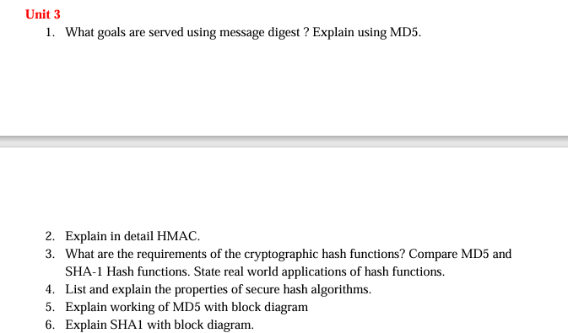



QUESTION : Explain in detail HMAC

Hash-based Message Authentication Code (HMAC) is a widely used cryptographic technique for verifying both the authenticity and integrity of a message. It involves a cryptographic hash function in combination with a secret key to produce a hash-based authentication code.

### How HMAC Works:

1. **Key Setup**: HMAC requires a secret key known only to the sender and receiver. This secret key is used to generate the HMAC.

2. **Hash Function Selection**: A cryptographic hash function, such as SHA-256 or SHA-512, is chosen for HMAC calculation. The choice of hash function depends on the desired level of security and the specific application requirements.

3. **Padding**: If necessary, the input message is padded to a specific block size required by the hash function.

4. **HMAC Calculation**:

- HMAC operates in two stages: an inner hash and an outer hash.

- **Inner Hash**: The input message is combined with the secret key using a specific operation, usually bitwise XOR. This combination is then hashed using the chosen hash function.

- **Outer Hash**: The result of the inner hash operation is hashed again using the chosen hash function, along with another key derived from the secret key (known as the "inner pad" or "outer pad"). The output of this hash operation is the HMAC.

5. **Verification**: The sender transmits both the message and the HMAC to the receiver. The receiver recalculates the HMAC using the received message and compares it with the received HMAC. If the calculated HMAC matches the received HMAC, the message is considered authentic and has not been tampered with.

### HMAC Calculation Formula:

The HMAC calculation formula can be expressed as follows:

```

HMAC(K, M) = H((K ⊕ opad) || H((K ⊕ ipad) || M))

```

Where:

- `K` is the secret key,

- `M` is the input message,

- `opad` and `ipad` are two fixed-size pads derived from the secret key,

- `||` denotes concatenation,

- `⊕` denotes bitwise XOR,

- `H()` denotes the chosen hash function.

### Example of HMAC Calculation:

Let's illustrate the HMAC calculation process using the SHA-256 hash function and a secret key.

#### Input:

- Message: "Hello, World!"

- Secret Key: "SecretKey123"

#### Steps:

1. **Key Setup**: `K = "SecretKey123"`

2. **Padding**: No padding required for this example.

3. **HMAC Calculation**:

- **Inner Hash**:

```

K XOR ipad = SecretKey123 XOR 0x36 (inner pad)

```

```

H((K XOR ipad) || M) = SHA-256(SecretKey123 XOR 0x36 || "Hello, World!")

```

- **Outer Hash**:

```

K XOR opad = SecretKey123 XOR 0x5C (outer pad)

```

```

HMAC = SHA-256(SecretKey123 XOR 0x5C || SHA-256(SecretKey123 XOR 0x36 || "Hello, World!"))

```

4. **Verification**: The sender transmits both the message and the calculated HMAC to the receiver. The receiver recalculates the HMAC using the received message and compares it with the received HMAC. If they match, the message is considered authentic.

### Summary:

Hash-based Message Authentication Codes (HMACs) provide a secure and efficient method for verifying the integrity and authenticity of messages in communication protocols. By combining a cryptographic hash function with a secret key, HMACs ensure that messages have not been tampered with during transmission and originated from a trusted source. They are widely used in various security protocols, including secure communication over networks and message authentication in digital signatures.

QUESTION: Compare HMAC CBC MAC and CMAC

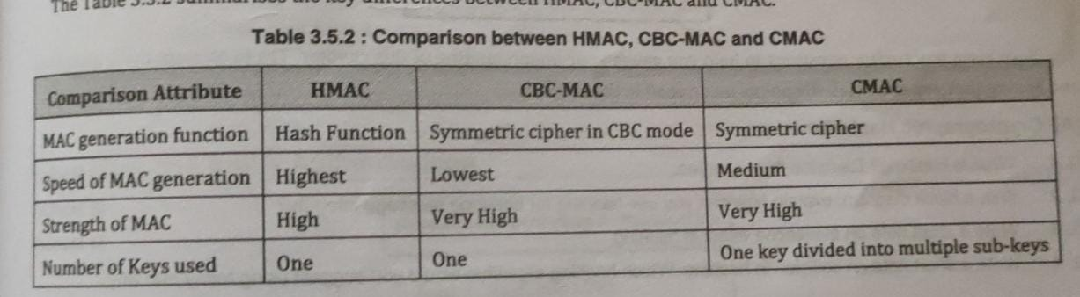

| **Feature** | **HMAC** | **CBC-MAC** | **CMAC** |
| --- | --- | --- | --- |
| Type | Authentication Code | Authentication Code | Authentication Code |
| Security | Secure, resistant to known attacks | Vulnerable to length extension attacks | Resistant to known attacks |
| Algorithm | Hash-based (Hash Function + Secret Key) | Block cipher-based (e.g., DES, AES) | Block cipher-based (e.g., AES) |
| Key Length | No restriction; depends on the hash function used | Same as the block cipher key size | Same as the block cipher key size |
| Output Length | Depends on the hash function | Typically fixed, determined by the cipher | Typically fixed, determined by the cipher |
| Padding | Not applicable; handles messages of any size | Padding required for short messages | Padding required for short messages |
| Parallelism | Sequential processing of the message | Parallel processing possible | Parallel processing possible |
| Resistance to Collisions | Provides collision resistance | Vulnerable to collision attacks | Provides collision resistance |
| Applications | Widely used in authentication protocols, digital signatures, secure communication | Used in authentication, integrity checking, and message authentication codes | Used in various security protocols, including TLS, IPsec, and WiFi security (802.11i) |
| Efficiency | Generally slower than CBC-MAC and CMAC | Fast, efficient for fixed-length messages | Fast, efficient for fixed-length messages |

This comparison highlights the differences between HMAC, CBC-MAC, and CMAC in terms of security, algorithm type, key length, output length, padding, resistance to collisions, applications, and efficiency. Each of these authentication codes has its strengths and weaknesses, making them suitable for different security requirements and applications.

give some more points

ChatGPT

Certainly, here are some additional points of comparison among HMAC, CBC-MAC, and CMAC:

| **Feature** | **HMAC** | **CBC-MAC** | **CMAC** |
| --- | --- | --- | --- |
| Message Processing | Operates on the entire message | Typically processes messages in blocks | Typically processes messages in blocks |
| Key Management | Uses a single secret key for all messages | Uses a single secret key for all messages | Uses separate keys for initialization and finalization |
| Initialization Vector (IV) | Not applicable | Requires an IV for each message | Requires an IV for each message |
| Mode of Operation | HMAC operates independently of block cipher modes | CBC-MAC operates in a chaining mode | CMAC operates in a one-key CBC-MAC mode |
| Resistance to Forgery | Provides strong resistance to forgery attacks | Vulnerable to certain forgery attacks | Provides strong resistance to forgery attacks |
| Padding Scheme | No specific padding scheme required | Padding scheme depends on the block cipher | Padding scheme depends on the block cipher |
| Security Analysis | Based on the security of the underlying hash function | Vulnerable to certain attacks based on the block cipher mode | Security analysis involves both the block cipher and MAC functions |
| Adoption | Widely adopted in various security protocols and applications | Less commonly used compared to HMAC and CMAC | Increasingly adopted in modern security protocols and applications |
| Standardization | Well-defined standards for HMAC exist | Standardization varies based on the block cipher used | Standardized in NIST SP 800-38B and ISO/IEC 9797-1 |

